Supplemental Primary Sources

Document C

Tarring & Feathering in Boston

This is a British illustration, printed in London, depicting the attack of a British Customs officer, John Malcom, in Boston. Broadsides were announcements, advertisements, and other notices printed and displayed in public spaces. Learn more about this image at www.gilderlehrman.org/history-resources/spotlight-primary-source/british-view-rebellious-boston-1774.

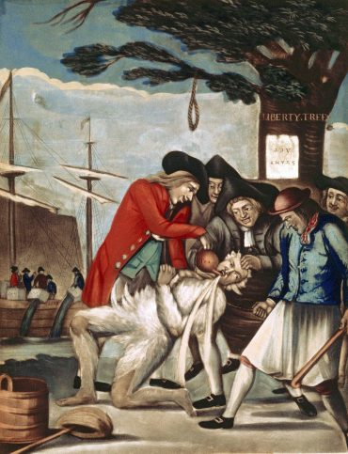

Image Source
“The Bostonian’s Paying the Excise-man, or Tarring & Feathering,” Philip Dawe, London, October 31, 1774. Gilder Lehrman Institute of American History.

Document D

Mr. Wood’s Affidavit Concerning the Mob at Salem
(Transcription modified for length and clarity.)
Robert Wood was an agent for the British Customs Service in Salem. He witnessed the September 1768 mob attack on Customs agent, Thomas Row. This is his statement to the Customs Service in Boston describing the attack. He names several Salem merchants who participated in the mob attack, including Richard Derby, his son Elias Hasket, and his son-in-law, George Crowninshield.

Copy of Mr. Wood’s affidavit concerning the mob at Salem
I Robert Wood, Tide Waiter of his Majesty’s Customs at Salem & Marblehead, do declare upon oath that I was present when Thomas Row was brought up to the Office in a cart drawn by the mob, who was tarred all over his shirt and trousers and covered with feathers, and I saw at the head of the mob Captain Lambert, George Crowninshield, Captain Richard Derby, Hasket Derby, Captain Putingham, and Henry Gardner, and Joseph Moses, who are the persons
I took most notice of at the head of the mob.
(Signed) Robert Wood.
Province of the The above named Robert
Massachusetts Bay Wood made oath to the truth
Suffolk 9th September of the Contents of this Writing
1768 by him signed before me.
(Signed) Nathanial Hatch, Just of the Peace

Vocabulary
- Affidavit: a written statement, confirmed by oath and often used as evidence in court
- Tide Waiter: a job title in the British Customs Service

Document D
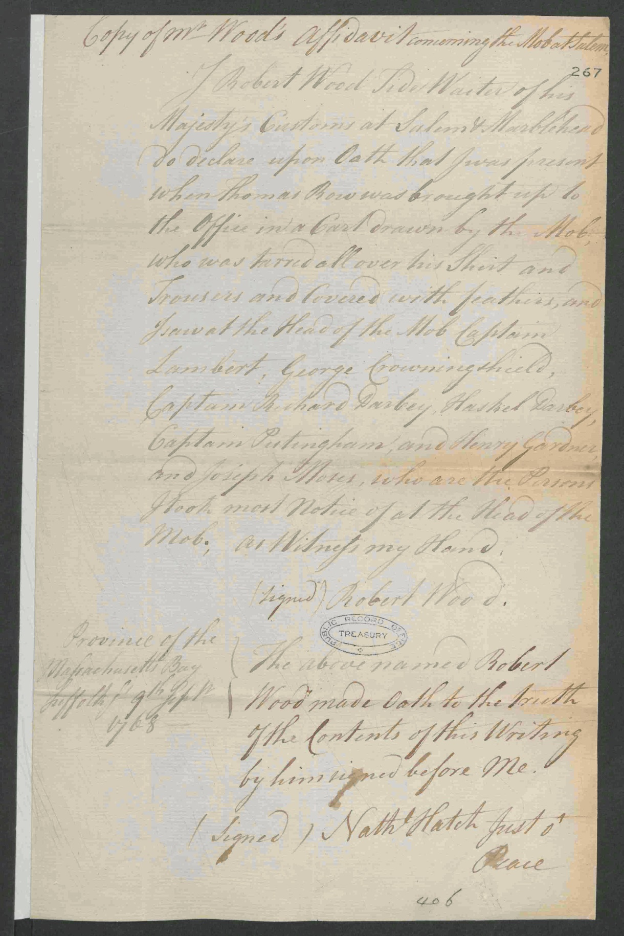
Image Source
The National Archives, United Kingdom. Copy of Mr. Woods's Affidavit concerning the Mob at Salem. September 9, 1768. T 1/465/267-268.

Document E

Cohasset Vital Records: Births
(Transcription modified for length and clarity.)
“Vital records” are records of life events such as birth, death, and marriage. These birth records are from the online database, “Early Vital Records of Massachusetts.” The free database holds information from church records, town records, private records, gravestone inscriptions, and newspaper articles from across Massachusetts.

Cohasset Births
…
…
NEGROES.
Asher, son of Jo and Phillis, negro servants of John Jacobs and Joseph Bates, Baptized December 29, 1745.
...
...
...
...
...
Obed, son of Jo and Phillis, Baptized August 28, 1748.
Phillys, daughter of Jane, negro woman of Joseph Bates, Baptized November 17, 1728.
…
…

Document E
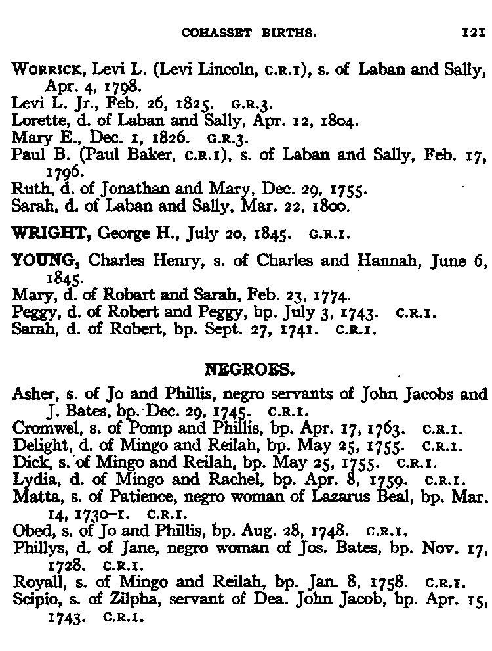

Image Source
Early Vital Records of Massachusetts, From 1600 to 1850. www.ma-vitalrecords.org

